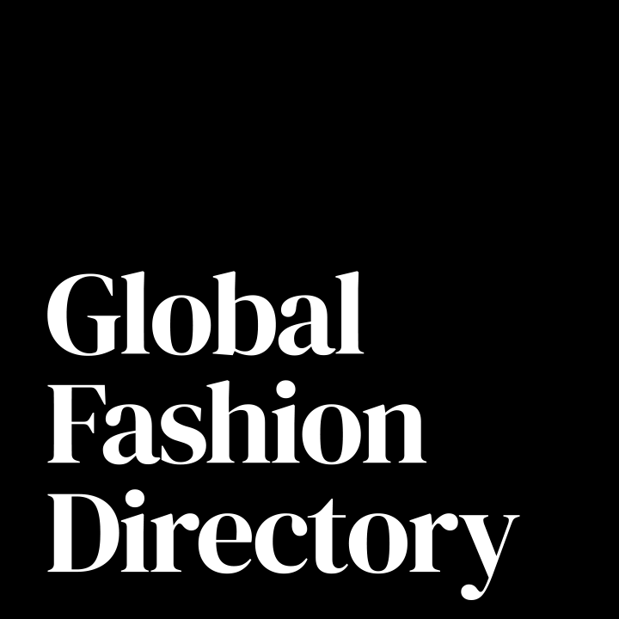
Modern Slavery
and Ethical Sourcing
Policy and Declaration

Legal Notice and Intended Use: This document is a customizable template provided by Global Fashion Directory LLC (“GFD”) to assist Member fashion brands in communicating their commitment to ethical sourcing and labor standards. It is intended for internal use by brands seeking to establish or formalize expectations with their suppliers, manufacturers, and other supply chain partners.
This Policy and Declaration is not legal advice. Brands must customize the contents based on their sourcing models, regional legal obligations, and operational risks. All references to [Brand Name] or [Insert Policy] must be replaced or updated with accurate, brand-specific information. Consultation with legal counsel is recommended before public distribution or contractual use.

Purpose and Scope: This Modern Slavery and Ethical Sourcing Policy and Declaration establishes foundational principles to:
- Promote ethical labor practices and human rights within brand-affiliated supply chains.
- Address risks related to modern slavery, child labor, and forced labor.
- Encourage transparent, fair, and legally compliant business practices across all tiers of the supply chain.
The policy draws on globally recognized frameworks, including:
- United Nations Guiding Principles on Business and Human Rights (UNGPs)
- OECD Guidelines for Multinational Enterprises
- ILO Core Conventions
- UK Modern Slavery Act (2015), Australian Modern Slavery Act (2018), and the California Transparency in Supply Chains Act (SB657)
By adopting and distributing this Declaration, brands and their partners affirm their role in upholding dignity, fairness, and accountability throughout their value chains. This template may be adapted for internal use by GFD Members. Any public use, distribution, or reproduction must include attribution to GFD. For permissions or licensing inquiries, contact: info@globalfashiondirectory.com

Modern Slavery and Ethical Sourcing Policy and Declaration

[Brand Name & Info]

1. Purpose and Scope
This Policy outlines the minimum ethical labor standards required by [Brand Name] ("Brand") of all manufacturers, suppliers, subcontractors, and service providers ("Suppliers") working with or on behalf of the Brand.
It is intended to prevent modern slavery, human trafficking, forced labor, and child labor across all tiers of the Brand's operations and supply chains.

2. Definitions
- Modern Slavery: Practices including forced labor, debt bondage, involuntary prison labor, human trafficking, and other forms of exploitation prohibited under international and national laws.
- Child Labor: Employment of persons under the legal minimum age as defined by applicable laws and the ILO conventions.
- Forced Labor Indicators: Includes retention of identity documents, withholding of wages, recruitment fee charges to workers, threats of penalties, and restriction of freedom of movement.

3. Supplier Commitments
Suppliers must:
- Prohibit all forms of modern slavery, human trafficking, forced labor, and child labor.
- Not retain workers' passports, IDs, or other personal documents.
- Ensure that workers are employed voluntarily, without coercion.
- Prohibit payment of recruitment fees by workers.
- Provide clear written contracts outlining employment terms in a language workers understand.
- Comply with all applicable labor, wage, working hours, and safety laws.
Suppliers are encouraged to map their supply chains, conduct risk assessments, and implement internal processes to detect and prevent labor abuses.

4. Monitoring and Compliance
The Brand reserves the right to:
- Conduct announced or unannounced audits or site visits.
- Request supply chain mapping, certifications, or third-party verification.
- Require corrective action plans if non-compliance is identified.
- Terminate the business relationship where remediation is not achieved or in cases of egregious violations.

5. Training and Capacity Building
Suppliers are encouraged to educate their employees, subcontractors, and supply chain partners on human rights and labor standards, and to promote awareness of ethical practices.

6. Reporting Mechanisms
Suppliers must:
- Establish grievance mechanisms allowing workers to confidentially report concerns.
- Cooperate with investigations related to any allegations of labor abuse.
- Immediately notify the Brand of any credible allegations or breaches related to modern slavery or labor violations.
Reports may also be submitted confidentially to [Insert Brand Contact Email].
7. Continuous Improvement
The Brand encourages Suppliers to actively improve labor standards, working conditions, and ethical sourcing practices over time.
This Policy may be updated periodically. Suppliers are expected to comply with any updated standards upon notice.

8. Declaration of Compliance

This declaration is made on behalf of (LIST ORGANISATION NAME) ________________________
I confirm that appropriate representatives of (LIST ORGANISATION NAME) _________________ have read this Policy and that (LIST ORGANISATION NAME) ______________________________ understands the contents of, and is committed to complying with, this Policy.

NAME OF SIGNATORY: _______________________________________
SIGNATURE: _______________________________________________
DATE: ____________________________________________________

